
Department of Information Technology
Bharati Vidyapeeth College of Engineering, Navi Mumbai
Academic Year 2019-2020

Mini Project Report
On
Snake and Ladder Game
Submitted in partial fulfillment of the requirements of the degree of
Bachelor of Engineering

By

Ankit Joshi[19]

Supervisor
Prof. S. M. Satre (B-I & B-II)

Bharati Vidyapeeth College of Engineering, Navi Mumbai
Department of Information Technology
Academic Year 2019-2020

CERTIFICATE

This is to certify that,
Ankit Joshi[19]

Class- SEIT Semester-III have completed the Mini Project “Snake and Ladder Game” Satisfactorily in the Department of Information Technology of as prescribed by the Mumbai University in the academic year 2019-2020.

Prof. S. M. Satre (B-I & B-II)
Mini Project Guide

ABSTRACT

A snakes and ladders game is a simple board game which can be played between two to four players. The four players race their token from start to finish by throwing their dice rolls. The board is played on numbered grid squares which are filled with ladders and snakes on selected boxes. The game is a game of chance and depends on the person’s luck. In these Project we have implemented these game using java which is Platform independent. The objective of the project is to make the much more interesting by introducing the GUI(Graphical user Interface) . The game is beautifully designed which makes it attractive to the children and also for adults to refresh their minds.The game has JDBC Connection which helps in storing the players data securely and retrieve that data to show the high score which makes game Competitive.

Keywords = JDBC, GUI

Contents

CHAPTER NO | TITLE | PAGE NO
1. | Introduction  1.1 Background  1.2 Features  1.3 Objective | 05  05  06
2. | Review of Literature | 07
3.  4.  5. | System Study  3.1 Existing System  3.2 Proposed System  3.3 System Requirements  Design Specification and Implementation  4.1 Input Design  4.2 Output Design  4.3 System Architecture  JDBC Connection | 09  10  10  11  12  17  18
6. | Limitations and Future Features  Conclusion | 19  20
 | References | 21

Chapter 1

Introduction

1.1Background

History

Snakes and Ladders originated in India as part of a family of dice board games that included Gyan chauper and pachisi (present-day Ludo and Parcheesi). According to some historians , the game was invented by saint gyandev in 13th centaury AD . Originally the game was used as part of moral instruction to children. The squares in which ladder were supposed to be stand for virtue and those housing for head of snakes were supposed to be evil. The game was transported England by colonial rulers in 19th century with some modification. The modified game was named Snake and Ladder and stripped of its moral and Religious aspects.

Today

Today Snake and Ladder is most widely played game among the small children. It is played on square grid board having 100 tiles. The Objective of the game is to be the first player to reach highest numbered spot on top row (100th tile).It is sheer Luck based Game where your position is decided by a random dice
Snakes sets you back while Ladder helps in advance quickly.
It is comparatively an easy game and can be played without network connectivity.

1.2 Features

This Project is the replica of Snake and Ladder game with some changes and the features of the project are:

1) GUI Interface

2) Multiplayer Game(2-4)

3) Database Connectivity

4) Platform Independent

1.3 Objectives

We made this game so that we could give our best in possible ways and show what we learned. The Objective of this Project are

1) To give GUI Interface to classic snake and Ladder board game.

2) To make it user friendly.

3) To provide an easy Interface.

4) To entertain people in their leisure time

5) To make it Competitive

Chapter 2

Literature Review

Snake and ladder is a game that has been around for a longest of time, unknown of the inventor , it is believed the game was played at a time as early as 2nd century BC. Since then, the game gained popularity for its playing system with vipers that demotes the player ‘s piece contrasting with the ladder that promotes to higher number plates. It is predated yet an interesting game for user to learn and be entertained. And as for programmers , it is a great way to begin the venture in coding, sequential processing of data and abstraction on different function together to form a unit.
After the popularity of computers sprang in the world, Snake and ladder was transformed to a computer game which has the same characteristics, only with automation controlling the dice.
The following Literature review attempt to demonstrate and support the grounds for game snake and ladder.
This game is programmed in java language. Java is a general-purpose programming language that is class-based, object-oriented, and designed to have as few implementation dependencies as possible. Sun Microsystems released the first public implementation as Java 1.0 in 1996.[25] It promised Write Once, Run Anywhere (WORA), providing no-cost run-times on popular platforms. This feature allows the game snake and ladder to be platform independent.
Swing is a graphical user interface library for the Java SE platform. It is possible to specify a different look and feel through the pluggable look and feel system of Swing. Clones of Windows, GTK+, and Motif are supplied by Sun. Apple also provides an Aqua look and feel for macOS. Where prior implementations of these looks and feels may have been considered lacking, Swing in Java SE 6 addresses this problem by using more native GUI widget drawing routines of the underlying platforms. The game frame, images , buttons , Gif , message dialogues were added in these game using jswing Library.
Java Database Connectivity (JDBC) is an application programming interface (API) for the programming language Java, which defines how a client may access a database. Sun Microsystems released JDBC as part of Java Development Kit (JDK) 1.1 on February 19, 1997.[1] Since then it has been part of the Java Platform, Standard Edition (Java SE). The JDBC classes are contained in the Java package java.sql and javax.sql. This allowed the game to store the records of the player in secured database and retrieve that to show the high score of the players.
Chapter 3

System Study

3.1 Existing System

Snake and ladder is an ancient indian board game which is played today manually. This game is played on a board having numbered gridded squares, snakes and ladder. In order to play these game it is necessary to have a board , dice and player pieces. This board is made up of cardboard or a plastic which can be easily broken down. Thus the manually played snake and ladder possess lot of limitation. We are trying to develop a system which makes , look and feel very interesting to play the game.

3.2 Proposed System

The Proposed system is designed to give a professional look and feeling GUI for snake and ladder game. These game has a frame which is designed beautifully. The frame has different components like
1) Message dialogues
2) Game board image, title Image , Snake GIFs, Players pieces , dice.
3) Buttons – Roll Button, Restart Button , High score Button
4) Background Color
5) Exit Option

Gameplay

Game play is very simple in snakes and ladder. The Player takes turn rolling the single die and moving up spaces according to dice. If the player lands on the head of a snake , the game piece will be sent back to the location of the snake s tail. If the game piece lands at the foot of a ladder , The piece will climb up to the top , thus significantly advances to 100th winning Position.

Game Rules

1) Initially the Player pieces are placed at 1st position.
2) The game starts with pressing role button.
3) If the player lands on the head of a snake, the game piece will be sent back to the location of the snake s tail.
4) If the game piece lands at the foot of a ladder, the piece will climb up to the top
5) The Player should be perfectly land on 100th position if it is going beyond that position then player’s position remains unchanged. Example if player is on 97th position its position will only change if dice rolls to 1,2,3 but not 4,5,6.
6) Only the winning player’s data will be saved in the database.
7) The High score can be viewed at any point of game.
8) Players can restart the game at any point.

3.3 System Requirements

Hardware Requirements

1) Window xp or above
2) Disk space 124 MB for

Software requirement

1) Java SE 8 version above
2) MySQL Connector driver
3) MySQL Database

Chapter 4

Design Specification and Implication

4.1 Input Design

The game initially starts with the welcome message(fig1). Then it takes number of players(fig2) input from the players fallowed by their names(fig3).


Fig(1)

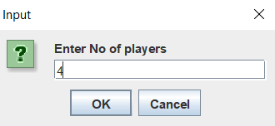
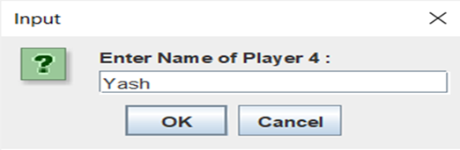

Fig(2) Fig(3)

4.2 Output Design

According to the given input by the user java frame will be designed and will be displayed( Fig4). The frame will display the game title, Snake and ladder Board, Roll Button, High Score Button , Restart Button and the Developers name, Players name and their pieces.

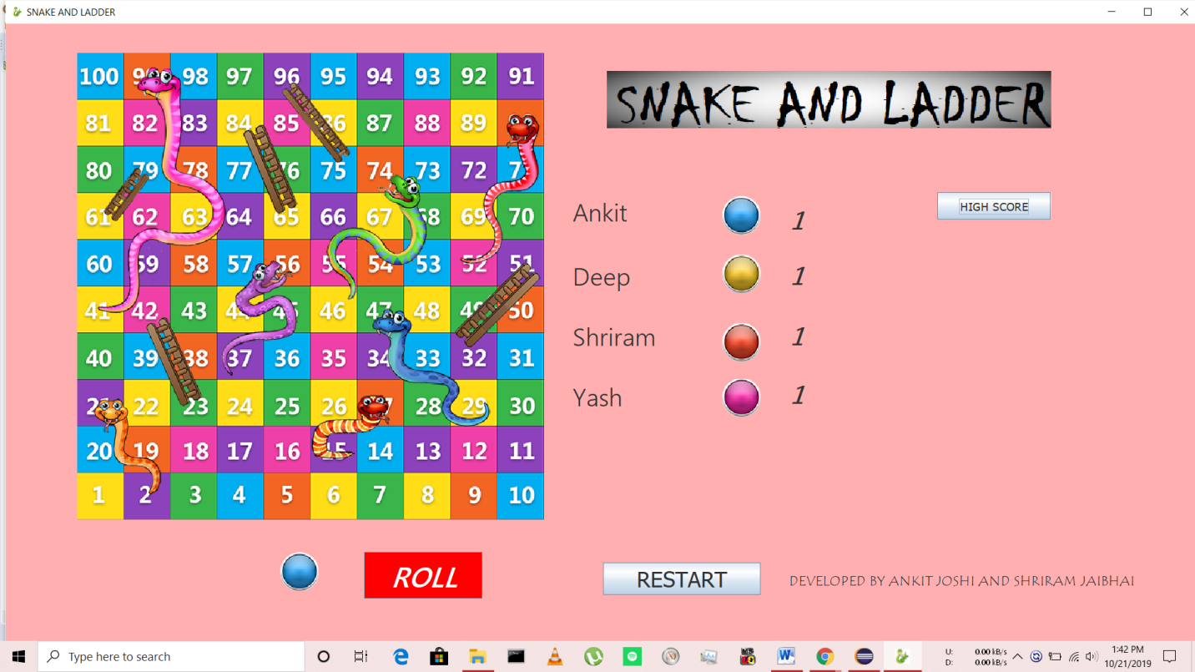

Fig(4)

Buttons

There are 3 Buttons present in these game
1) Roll Button
2) High Score
3) Restart

1) Roll Button

The Game begins by pressing the roll button. Each Player is assigned a circle with different colors as their symbols. This symbol is present at side of roll button to indicate which player chance it is. After Pressing the Roll Button dice image pops up with the number. According to it player position is modified and is displayed on the board (Fig5). If there is no snake and ladder over there player’s position remains same (Fig6 and Fig7). However if there is any snake or ladder respective message pops up and the player position changes. The Snake gif is displayed on frame when it is eaten by a snake(Fig6).

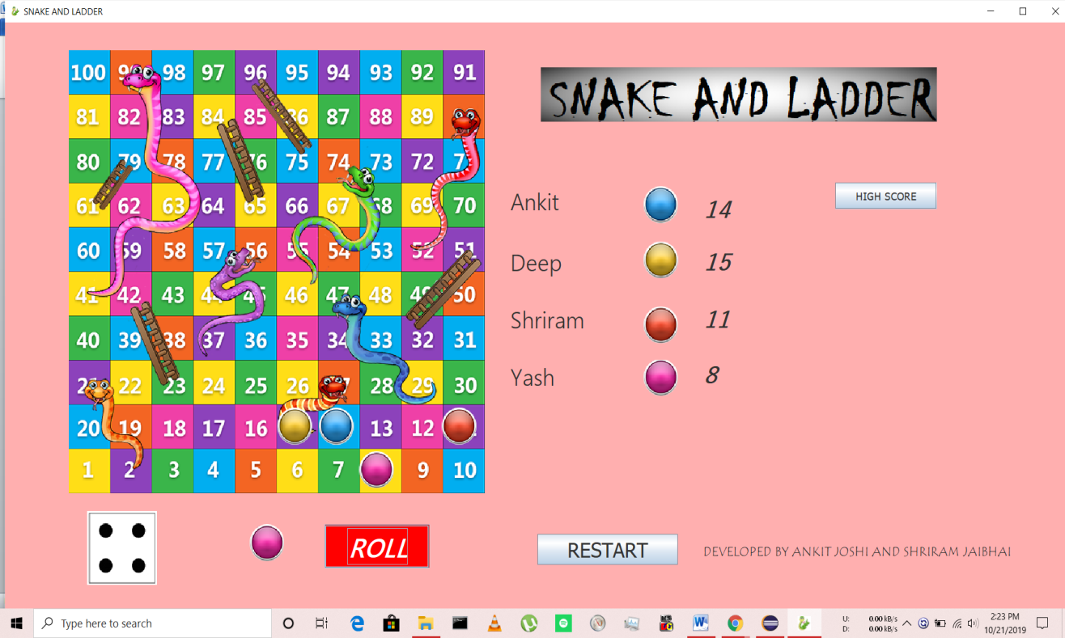
Fig(5)

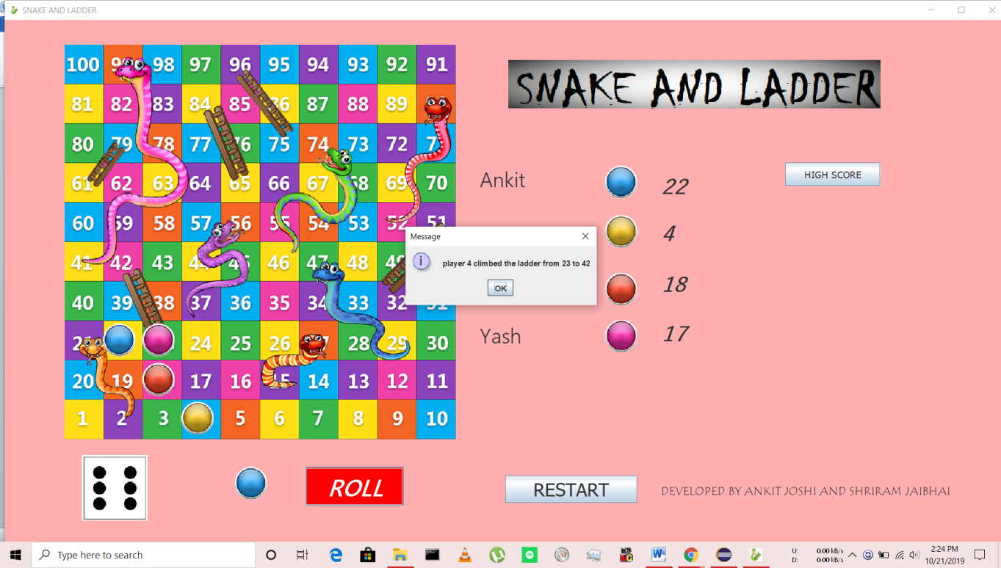
Fig(6)

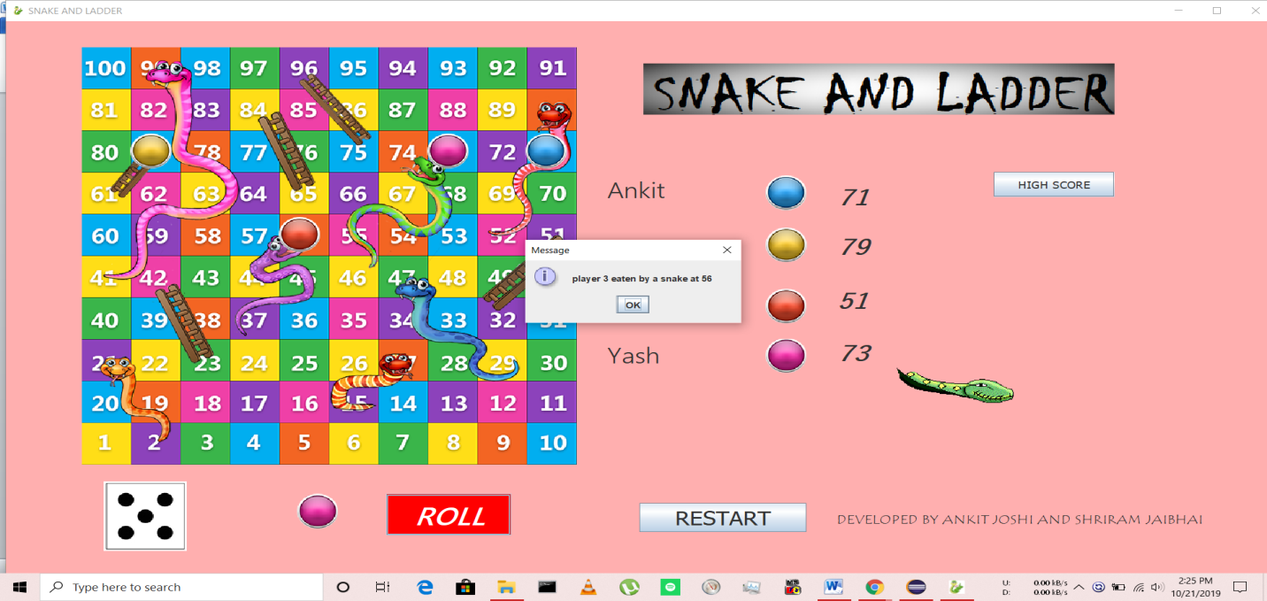
Fig(7)

2) Restart Button

Players can restart the game at any point(Fig8) or after the game is completed by pressing Restart Button(Fig9).

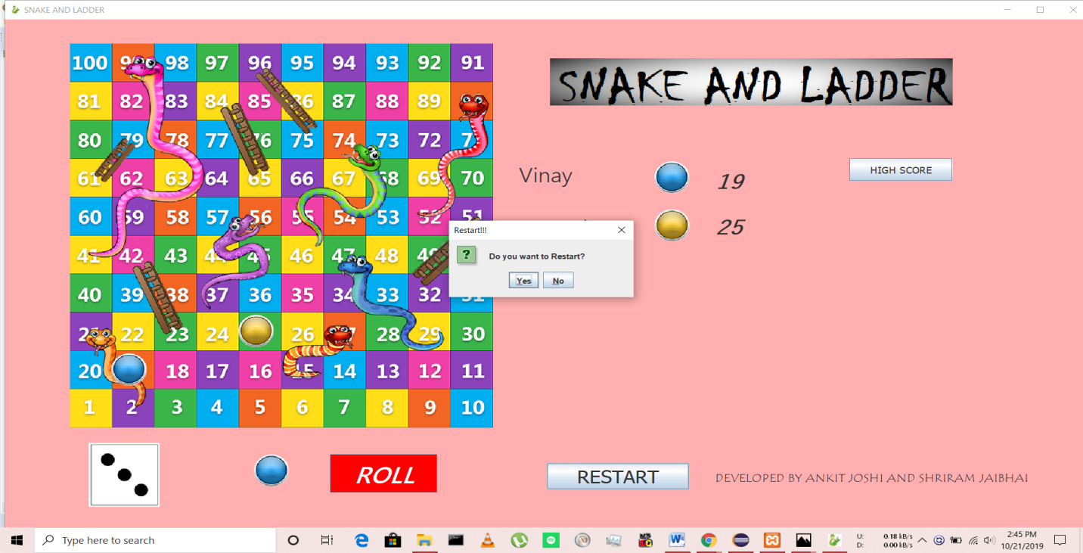
Fig(8)
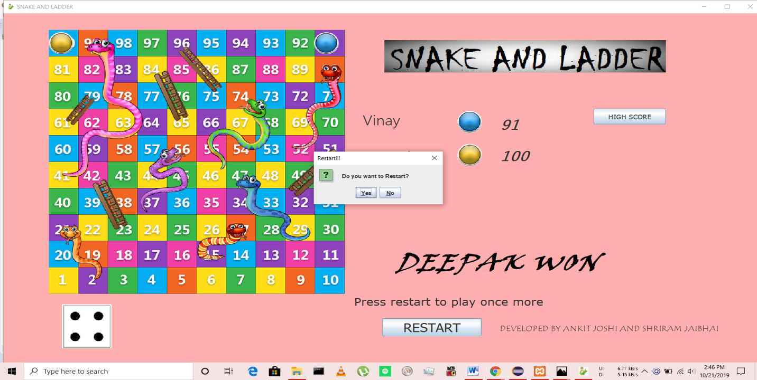
Fig(9)

3) High Score Button

It retrieves the data from the database(Fig10) by selecting the record having minimum rolls and then displays it(Fig11).

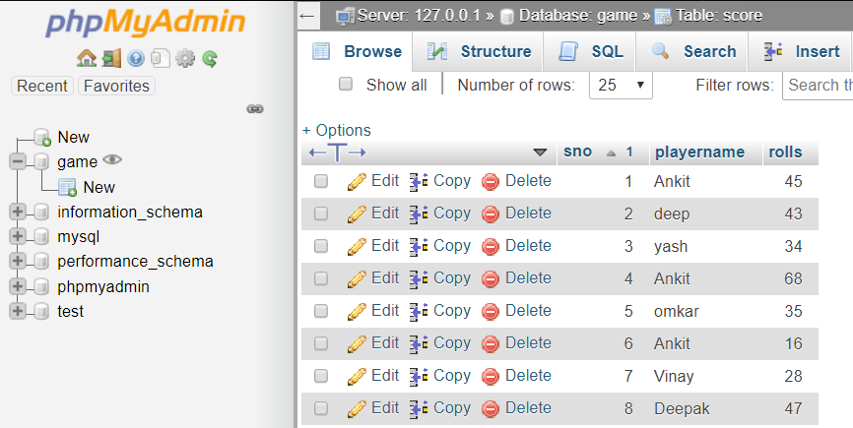
Fig10

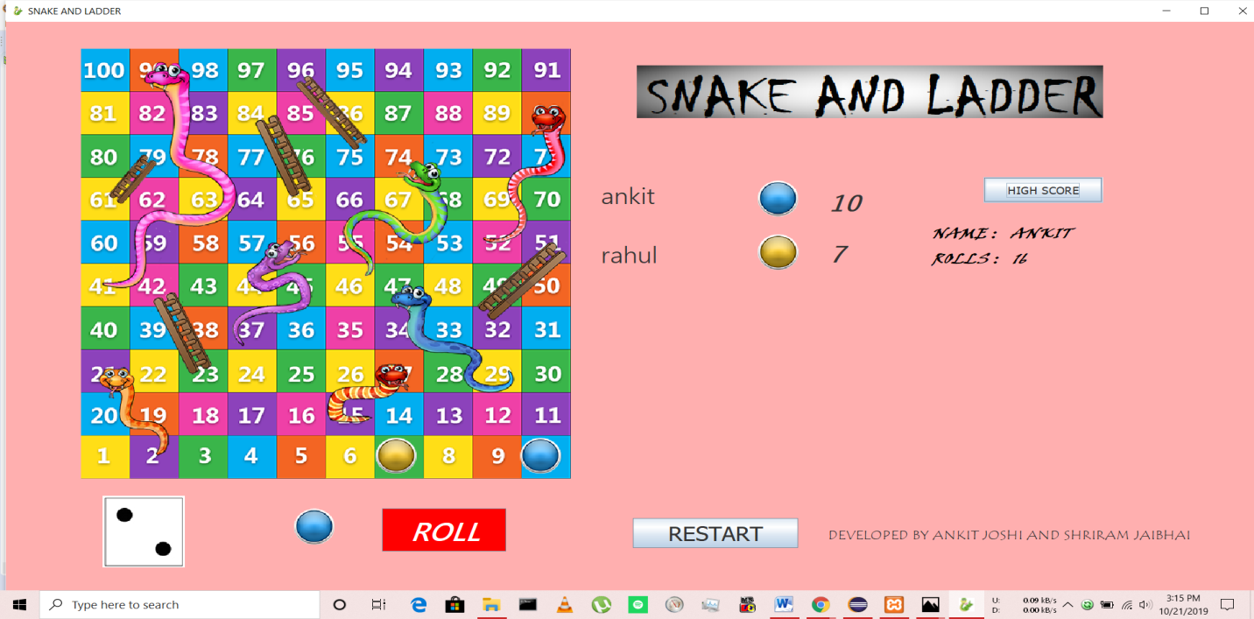
Fig11

4.3 System Architecture

The game frame has on one Jpanel which contains jlabels which helps in displaying various components at different locations. JLabel is a class of java Swing. JLabel is used to display a short string or an image icon. JLabel can display text, image or both. For Showing movement of player pieces from one position to other we have created 100 Jlabels(Fig11) according to it we have modified the size of snake and ladder board(Fig12).

100 | 99 | 98 | 97 | 96 | 95 | 94 | 93 | 92 | 91
81 | 82 | 83 | 84 | 85 | 86 | 87 | 88 | 89 | 90
80 | 79 | 78 | 77 | 76 | 75 | 74 | 73 | 72 | 71
61 | 62 | 63 | 64 | 65 | 66 | 67 | 68 | 69 | 70
60 | 59 | 58 | 57 | 56 | 55 | 54 | 53 | 52 | 51
41 | 42 | 43 | 44 | 45 | 46 | 47 | 48 | 49 | 50
40 | 39 | 38 | 37 | 36 | 35 | 34 | 33 | 32 | 31
21 | 22 | 23 | 24 | 25 | 26 | 27 | 28 | 29 | 30
20 | 19 | 18 | 17 | 16 | 15 | 14 | 13 | 12 | 11
1 | 2 | 3 | 4 | 5 | 6 | 7 | 8 | 9 | 10

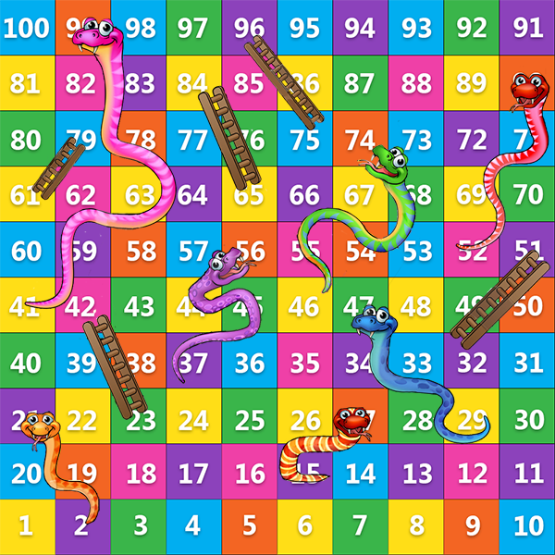

Fig10 Fig11

Both the Fig will have same height and width, In our project it is 60 x 60. These 100 jlabels are labeled are numbered same as board. Then we use another jlabel on this box of hundred jlabels which displays the board image. Thus we aligned every squares of the board with the all the Jlabels.
Thus to show players position we have remove its previous position by removing the image on that particular jlabel and display its new position on respective jlabel which indirectly displays it on the image board.

JFrame
Restart Button
High score Button
ROLL BUTTON

Disposes the Frame
Decides which player piece to move
Retrieval of data from the database

Dice image is placed and player’s new position is returned
Starts New Game

Showing the record the correct record
Remove the previous image of the piece

Sets the image on new position

Checks multiple conditions
Snake or Ladder

Players position valid or not
Player winning

Modifies the position

MySql Database

Player data Registered in database
Chapter 5

JDBC Connection

Java Database Connectivity (JDBC) is an application programming interface (API) for the programming language Java, which defines how a client may access a database. It is a Java-based data access technology used for Java database connectivity. It is part of the Java Standard Edition platform, from Oracle Corporation. It provides methods to query and update data in a database, and is oriented towards relational databases

XAMPP is a software distribution which provides the Apache web server, MySQL database (actually MariaDB), Php and Perl (as command-line executables and Apache modules) all in one package. It is available for Windows, MAC and Linux systems. No configuration is necessary to integrate Php with MySQL. The database of the game was made using phpMydmin.

This database saves the Players data after player wins the match. Here in the fig11 shows the table present in our game database which stores the player name and number of rolls required to win the match. This data is further used to retrieve the player having minimum rolls and display it has high scorer.

Fig10
Chapter 6

Limitations and Features

6.1 Limitations

1) The game does not have any graphical animations.
2) Maximum Players to play these game are 4.
3) The game is implemented using single thread.
4) Players cannot save or load the previous left game.

6.2 Future Features

1) Graphical animation can be introduced in the game for example to show rolling of dice or movement of player pieces from one place to another.
2) The Number of Players playing the game can be increased.
3) The game can be implemented using multithreading to increase the speed of game
4) The service of JDBC connection can be extended to save the unfinished game data and load it play afterward.
5) Music system can be introduced in the game which will make more attractive

Conclusion

The primary objective of the project was to see how java, an object based oriented language can be used to make an simple board game. Snake and Ladder is ancient game which is played today by many small children. While making these project we were able to learn the concept of GUI in java which made game attractive and interesting. Database connectivity in project helped in giving additional features to game and make it more competitive. This game is platform independent which means it can run on any machine.

References

1) XAMPP - https://www.cs.wcupa.edu/rkline/index/xampp.html
2) Wikipedia

